Demand Forecasting means estimating future customer demand for a product or service based on historical data and relevant factors. Inventory Optimization is the strategic management of inventory levels to ensure that the right amount of goods is available at the right time to meet customer demand while minimizing costs.

# Demand Forecasting and Inventory Optimization: Process We Can Follow

Demand Forecasting involves predicting the quantity and pattern of customer orders, which is crucial for businesses to efficiently allocate resources, manage inventory, and plan production. Accurate demand forecasting enables companies to meet customer needs, avoid overstocking or understocking, and optimize their supply chain operations.

Inventory Optimization aims to strike a balance between having sufficient stock to meet demand without carrying excess inventory that ties up capital and storage space. Effective inventory optimization helps businesses reduce carrying costs, improve cash flow, and enhance customer satisfaction.

These concepts are especially relevant in retail, manufacturing, and distribution, where managing supply and demand dynamics is essential for profitability and customer satisfaction.

For the task of Demand Forecasting and Inventory Optimization, we can start by gathering historical sales data, customer orders, and relevant external factors like seasonality, promotions, and economic trends. Then, we can use appropriate forecasting models like ARIMA, SARIMA, or exponential smoothing for demand forecasting. Then, we can use the demand forecasts to optimize inventory levels by implementing strategies like reorder points, safety stock, and economic order quantity (EOQ) calculations.

Now lets visualize demand and inventory over time graphs by performing exploratory data analysis:

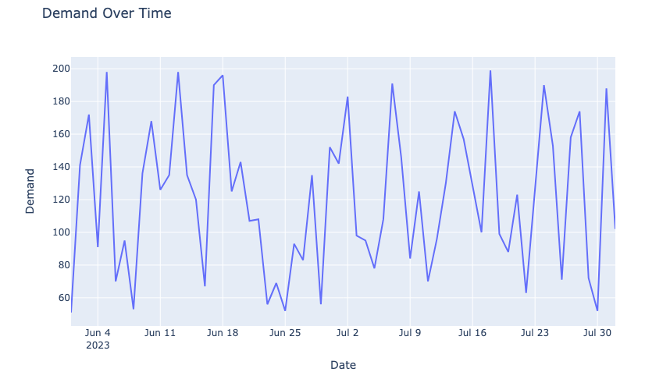

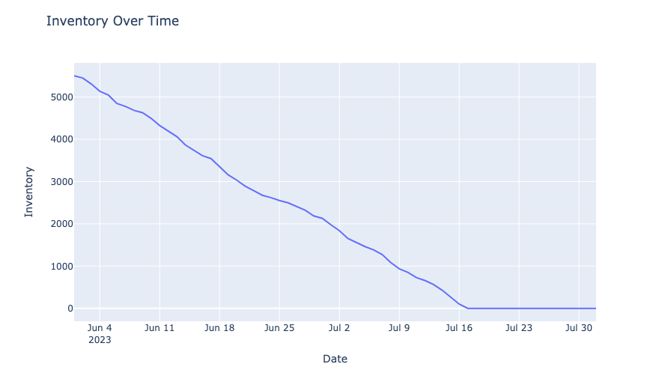

I can see seasonal patterns in the demand. We can forecast the demand using SARIMA. Let’s first calculate the value of p and q using ACF and PACF plots:

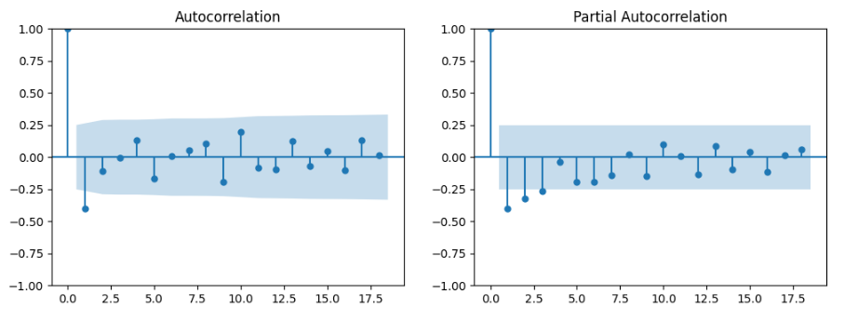

The value of p, d, and q will be 1, 1, 1 here. Now let’s see how we can optimize inventory according to the forecasted demand for the next ten days:

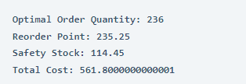

Optimal Order Quantity: 236

– The optimal order quantity refers to the quantity of a product that should be ordered from suppliers when the inventory level reaches a certain point. In this case, an optimal order quantity of 236 units has been calculated.

Reorder Point: 235.25

– The reorder point is the inventory level at which a new order should be placed to replenish stock before it runs out. In this case, a reorder point of 235.25 units has been calculated, which means that when the inventory reaches or falls below this level, an order should be placed to replenish stock.

Safety Stock: 114.45

– Safety stock is the additional inventory kept on hand to account for uncertainties in demand and supply. It acts as a buffer against unexpected variations in demand or lead time. In this case, a safety stock of 114.45 units has been calculated, which helps ensure that there’s enough inventory to cover potential fluctuations in demand or lead time.

Total Cost: 561.80

– The total cost represents the combined costs associated with inventory management. In this case, the total cost has been calculated as approximately 561.80 units based on the order quantity, reorder point, safety stock, and associated costs.

By analyzing these values, you can make informed decisions about how much inventory to order and when to place orders to ensure a smooth supply chain and customer satisfaction while minimizing costs.